INDEX

|  |  |
| --- | --- |
| **Sr. No.** | **Title** |
| **1.** | **Introduction** |
| **2.** | **Gantt Chart** |
| **3.** | **Organization Overview :**  a. History  b. Organizational Chart  c. Present System  d. Limitations of Present System |
| **4** | **Proposed System:**  a. Proposed System  b. Benefits of proposed system  c. Feasibility Study  d. Prototype Model |
| **5.** | **System Documentation :** |
|  | a. Context Level Diagram |
|  | b. Entity Relationship Diagram |
|  | c. Event Table |
|  | d. DFD |
|  | e. System Flow Chart |
|  | f. Structure Chart |
|  | g. Map |
|  | h. Use case Diagram |
|  | i. Component Diagram |
|  | j. Sequence Diagram |
|  | k. ERD conversion Diagram |
|  | l. Form List |
|  | m. Table List |
|  | n. Report List |
|  | o. Naming Conventions |
| **6.** | **System Screen** |
| **7.** | **System Control And Standard** |
| **8.** | **Program Documentation** |
| **9.** | **Testing** |
| **10.** | **Software and Hardware Specification** |
| **11.** | **Conclusion** |
| **12.** | **Bibliography** |

**Introduction**

**Introduction to Project**

With tremendous increase in technology, information technology is a fast developing field. Technology which is in vogue today might become redundant tomorrow. This ever changing scenario makes it possible to provide the latest and most modern IT solutions to various business and institutions.

I am doing my project on **Cosmetic Shop Management.** There is the need for efficient management of a network based system for handling customer orders.

This project is an endeavor to provide a solution to this. The proposed system enables an administrator to keep track of customer orders and maintaining records of the customers. He can view the submitted requirements made by the customer. He can also view the reports generated by him and can also sent approvals or rejections instantly.

Thus the project is a sincere effort in simplifying the task of administrators in an easily usable format.

I finalized to make this project and hence planned to develop this system using Visual Studio 2008 for front end and SQL as the Back End.

**GANTT CHART**

|  |  |  |  |  |  |  |  |  |  |  |  |  |  |  |  |
| --- | --- | --- | --- | --- | --- | --- | --- | --- | --- | --- | --- | --- | --- | --- | --- |
| 1. | Project Search | 1 |  |  |  |  |  |  |  |  |  |  |  |  |  |
| 2. | Finalization |  | 2 |  |  |  |  |  |  |  |  |  |  |  |  |
| 3. | Allocation |  |  | 3 |  |  |  |  |  |  |  |  |  |  |  |
| 4. | Investigation of System Requirements |  |  |  | 4 |  |  |  |  |  |  |  |  |  |  |
| 5. | Data & Process Modeling |  |  |  |  | 5 |  |  |  |  |  |  |  |  |  |
| 6. | System Design |  |  |  |  |  | 6 |  |  |  |  |  |  |  |  |
| 7. | Program Design |  |  |  |  |  |  |  | 7 |  |  |  |  |  |  |
| 8. | Program Coding |  |  |  |  |  |  |  |  | 8 |  |  |  |  |  |
| 9. | Unit Testing |  |  |  |  |  |  |  |  |  | 9 |  |  |  |  |
| 10. | System Integration |  |  |  |  |  |  |  |  |  |  |  | 10 |  |  |
| 11. | System Implementation |  |  |  |  |  |  |  |  |  |  |  |  | 11 |  |
| 12. | Acceptance Testing |  |  |  |  |  |  |  |  |  |  |  |  |  | 12 |
|  |  |  |  |  |  |  |  |  |  |  |  |  |  |  |  |
|  |  | W1 W2 W3 W4 W5 W6 W7 W8 W9 W10 W11 W12 W13 W14 W15 W16 W17 W18 W19 W20 W21 | | | | | | | | | | | | | |
|  |  | | | | | | | | | | | | | | |

**LIMITATION OF THE PRESENT SYSTEM:**

Before starting the project we have to study its limitations and objective some of them are:-

* All the processes of this management are done manually in the form of paper work and the records are stored in the registers. In such cases there are frequent chances of data redundancy and data is ease to lose.
* All the introductions related to the patients and others printed on the papers, this activity generates the chances of data lost.
* All the bills structures are done by hand written; sometimes it produces mistakes in calculation.
* This system is very time consuming and require lost of manpower

**PROPOSED SYSTEM:**

Objective is to overcome the major limitation of the existing enabling effective management of the customer details thereby improving the performance.

* With improved computerization being involved in the maintenance of customer details, error and inconsistencies can be kept at par.
* Easy retrieval of data will be made possible by finding techniques.
* Validation of data will ensure only accurate, valid and complete data is stored in the database.
* Proper monitoring of the processes from customer registration to activation. Report generation will help make it easy to analyze the performance at the Bank.
* This will be much less time consuming comparing to existing system.

**ADVANTAGES OF PROPOSED SYSTEM :-**

* With improved computerization being involved in the maintenance of Patient, Doctors, and Staff details. Error and inconsistencies can be kept at per.
* Validation of data will be ensure only accurate valid and complete data stored in the database.
* Easy retrieval or data will be made possible by finding techniques.
* Report generation will help made its easy to analyze the performance or clinic Administration.

**OBJECTIVE AND SCOP OF PROPOSED SYSTEM:**

* The objectives of the proposed system are to overcome the major limitation of existing system enabling effective management of the customer details thereby improving the performance of SHOP ADMINISTRTION.
* The system will store all the basic data processing needs the shop management.

**Feasibility study**

A feasibility study is undertaken to determine to the possibility or probability of either improving the existing system or developing a completely new system. It helps to obtain the overview of the problem and to get a rough assessment of whether other feasible solution exists.

NEEDS FOR FEASIBILITY STUDY:

The feasibility study is needed for following things:-

* Answer the questions whether a new system is to be installed or not?
* Determine the potential of the existing system.
* Improve the existing system.
* Know what should be embedded in the new system.
* Define the problems and objectives involved.
* Avoid costly repairs at later stage when system is implemented.
* Avoid crash implementation of the new system.
* Avoid the ‘Hardware approach’ i.e. getting a computer first and then deciding how to use it.

The Feasibility study is divided in to three parts:-

* TECHNICAL FEASIBILITY
* ECONOMIC FEASIBILITY
* OPERATIONAL FEASIBILITY
* **ECONOMIC FEASIBILITY**

Economic analysis is most frequently used for evaluation of the effectiveness of the system. More commonly known as cost/benefit analysis the procedure is to determine the benefit and saving that are expected from a system and compare them with costs, decisions is made to design and

Implement the system.

This part of feasibility study gives the top management the economic justification for the new system. This is an important input to the management the management, because very often the top management does not like to get confounded by the various technicalities that bound to be associated with a project of this kind. A simple economic analysis that gives the actual comparison of costs and benefits is much more meaningful in such cases.

In the system, the organization is most satisfied by economic feasibility. Because, if the organization implements this system, it need not require any additional hardware resources as well as it will be saving lot of time.

* **TECHNICAL FEASIBILITY**

Technical feasibility centers on the existing manual system of the test management process and to what extent it can support the system.

According to feasibility analysis procedure the technical feasibility of the system is analyzed and the technical requirements such as software facilities, procedure, inputs are identified. It is also one of the important phases of the system development activities.

The system offers greater levels of user friendliness combined with greater processing speed. Therefore, the cost of maintenance can be reduced. Since, processing speed is very high and the work is reduced in the maintenance point of view management convince that the project is operationally feasible.

* **BEHAVIOURAL FEASIBILITY**

People are inherently resistant to change and computer has been known to facilitate changes. An estimate should be made of how strong the user is likely to move towards the development of computerized system. These are various levels of users in order to ensure proper authentication and authorization and security of sensitive data of the organization.

**The prototyping model**

The mode is used for developing the “Exam Tool” is the prototyping model.

Prototyping Model is based on the idea of developing an initial implementation, exposing this to user comment and defining this through many until an adequate system has been developed.

Benefits of prototyping model

The prototyping paradigm begins with requirements gathering. Developers and customers meet and define the overall objective for the software, identify the requirements and outline the areas where further definitions are necessary.

The prototype design, is often, quite different from that of the final system. The benefits of developing a prototype early in the software process are:

* Misunderstanding between software developers and users may be identified, as the functions are demonstrated.
* Missing user services may be detected.
* Difficult to use or confusing user services may be indentified and refined.
* Software development staff may find incompleteness and inconsistency in requirement as the prototype is developed.
* A working albeit limited systems is available quickly to demonstrate the feasibility and usefulness of the application to the management.
* The prototype serves as a basis for writing the specification for a production quality system. Though the principle purpose of prototyping is to validate software requirements, software prototype also has other uses.
* A prototype system can be used for training users before the formal system has been delivered.
* Prototype can be run back-to-back tests. This reduces the need for tedious manual checking of test run. The same test is given to both the prototype and the system under test to look for differences in the final results and thereby making necessary changes. Thus prototype serves as a technique of risk reduction.

**Selecting the prototype approach**

The prototype paradigm can be either close ended (throwaway prototyping) or open ended(evolutionary prototyping). Before selecting closed or open-ended approach, it is necessary to determine whether the system to be built is suitable for prototyping or not. This is decided depending on application area, complexity, and customer characteristics and projects characteristics. Prototyping or evolutionary prototyping. The throwaway is developed to understand the system requirements while the evolutionary prototype evolves through a number of versions to the final system.

**DIAGRAMS**

**CONTEXT LEVEL DIAGRAM**

A System Context Diagram (SCD) in [software engineering](http://en.wikipedia.org/wiki/Software_engineering) and [systems engineering](http://en.wikipedia.org/wiki/Systems_engineering) is a [diagram](http://en.wikipedia.org/wiki/Diagram) that represents the actors outside a system that could interact with that [system](http://en.wikipedia.org/wiki/System). This diagram is the highest level view of a [system](http://en.wikipedia.org/wiki/System), similar to [Block diagram](http://en.wikipedia.org/wiki/Block_diagram), showing a, possibly [software](http://en.wikipedia.org/wiki/Software_system)-based, system as a whole and its [inputs](http://en.wikipedia.org/wiki/Input/output) and [outputs](http://en.wikipedia.org/wiki/Output) from/to external factors.

Account Checking

Cosmetic Shop Management System

Customer

Admin

(User)

Supplier

Staff

(User)

Request for Item

Supply of Item

Login

Customer Record,

Create bills

Request for Item

Supply of Item

Login

Man. Login Details

Bill

Bill

Payment

Payment

Context Level Diagram for Cosmetic Shop Management System

**Choice of Product**

**Customer**

**Order**

**Suggestions**

**Inquiry**

**Bill**

**Products**

**Supplier**

**ENTITY RELTIONSHIP DIAGRAM (ERD)**

**Entity-Relationship Diagram**

* This document is an entity-relationship diagram, or “ERD,” for a system to manage Inventory Management System.
* An ERD is a model that identifies the concepts or entities that exist in a system and the relationships between those entities.
* An ERD is often used as a way to visualize a relational database: each entity represents a database table, and the relationship lines represent the keys in one table that point to specific records in related tables.
* ERD may also be more abstract, not necessarily capturing every table needed within a database, but serving to diagram the major concepts and relationships.
* This ERD is of the latter type, intended to present an abstract, theoretical view of the major entities and relationships needed for management of electronic resources.
* It may assist the database design process for an e-resource management system, but does not identify every table that would be necessary for an electronic resource management database.

ERD for Cosmetic Shop Management System

**1/M**

**1**

**0/M**

**1**

**1**

**1**

**Choice of Product**

**Customer**

**Order**

**Suggestions**

**Inquiry**

**Bill**

**1/M**

**Products**

**Supplier**

**1**

**1/M**

**1**

**1/M**

**1/M**

**1**

**1**

**Event Table**

The event table is a table of data that is typically written to the [log file](http://www.neurobs.com/pres_docs/html/09_data_reporting/01_logfiles/index.html) for each [scenario](http://www.neurobs.com/pres_docs/html/03_getting_started/04_scenarios/index.html) and also appears in the [Analysis window](http://www.neurobs.com/pres_docs/html/09_data_reporting/02_analysis_features/02_using_the_analyzer.htm). The event table contains timing information about specific events that occur during the scenario.

|  |  |  |  |  |  |
| --- | --- | --- | --- | --- | --- |
| **Event** | **Trigger** | **Source** | **Activity** | **Response** | **Destination** |
| Customer Registration | Ask for Item | Customer | Create new Bill | Customer registered | Sells Person |
| Sells Person check availability of Stock | Stock Inquiry | Customer | Look up Stock availability | Stock details | Customer |
| Customer select Item | Enquiry about Item | Sells Person | selecting | Item selected | Customer |
| Sells Person gives Item to Customer | Check the Price | Staff | Look up in register | Item given | Customer |
| Produce Bill report | Quantity inquiry | Sells Person | Checking the Stock | Bill report | Customer |
| Customer Checks data | Ask for Bill | Sells  Person | checking | Data checked | Accountant |
| Summary of Bill report | End of day | Sells Person | Produce Bill summary report | Bill summary report | Admin (Owner) |

**System Chart**

A flowchart that emphasizes the component operations which make up a system.

**BILL**

**GENERATES**

**BILL**

**CUSTOMER**

**EMPLOYEE**

**DEBIT / CREDIT**

**CUSTOMERDATABASE**

**EMPLOYEEDATABASE**

**DEBIT / CREDIT DATABASE**

**PRODUCT / SUPPLIER DATABASE**

**CUSTOMER**

**EMPLOYEE**

**SHOP ACCOUNT**

**Cosmetic Shop Management**

**PRODUCTS**

**PRODUCTS**

**BILL DATABASE**

**Structure chart**

A **Structure Chart** (SC) in [software engineering](http://en.wikipedia.org/wiki/Software_engineering) and [organizational theory](http://en.wikipedia.org/wiki/Organizational_theory) is a [chart](http://en.wikipedia.org/wiki/Chart), which shows the breakdown of the [configuration system](http://en.wikipedia.org/wiki/Configuration_system) to the lowest manageable levels.

This chart is used in [structured programming](http://en.wikipedia.org/wiki/Structured_programming) to arrange the program modules in a tree structure. Each module is represented by a box, which contains the module's name. The tree structure visualizes the relationships between the modules.

**Cosmetic Shop Management System**

**Bill**

**Customer**

**Peripherals**

**Supplier / Order**

**Reports**

Customer details

Bill details

Order

Details

Peripherals details

**MENU TREE**

About

Exit

About

Project

Reports

Bills

Employee Salary

Transaction

Lock

Delete

User

Register

User

Employee

Details

Customer

Details

Products

Login Screen

Bill

Cosmetic Shop Management System

**Usecase Diagram**

A use case diagram in the [Unified Modeling Language](http://en.wikipedia.org/wiki/Unified_Modeling_Language) (UML) is a type of behavioral diagram defined by and created from a [Use-case analysis](http://en.wikipedia.org/wiki/Use-case_analysis). Its purpose is to present a graphical overview of the functionality provided by a system in terms of [actors](http://en.wikipedia.org/wiki/Actor_(UML)), their goals (represented as [use cases](http://en.wikipedia.org/wiki/Use_case)), and any dependencies between those use cases.

Admin

Staff

Customer

**Data Flow Diagram (DFD)**

A **data flow diagram** (**DFD**) is a graphical representation of the "flow" of data through an [information system](http://en.wikipedia.org/wiki/Information_system). DFDs can also be used for the[visualization](http://en.wikipedia.org/wiki/Data_visualization) of [data processing](http://en.wikipedia.org/wiki/Data_processing) (structured design).

CUSTOMER DETAILS

**Customer**

**Customer**

**Details**

**1.2**

**UPDATE**

**1.3**

**DELETE**

**1.1**

**ADD**

**1.4**

**SEARCH**

**CUSTOMER**

**DETAILS**

**1.0**

**Customer**

**Customer Information**

**ACCOUNT**

**1.1**

**ADD**

**ACCOUNT**

**Customer**

**1.1**

**ADD**

**Customer**

**Customer**

**1.3**

**DELETE**

**Customer**

**Customer**

**1.2**

**UPDATE**

**Customer**

**Customer**

**1.4**

**SEARCH**

**Customer**

2) BILL ORDER DETAILS

**Order Information**

**Order**

**Order**

**Details**

**2.2**

**UPDATE**

**2.3**

**DELETE**

**2.1**

**ADD**

**2.4**

**SEARCH**

**Order**

**DETAILS**

**2.0**

**Bill Order**

3.DEALER / PRODUCT DETAILS

**Product**

**Information**

**PRODUCT**

**e**

**3.2**

**UPDATE**

**3.3**

**DELETE**

**3.1**

**ADD**

**3.4**

**SEARCH**

**PRODUCT**

**DETAILS**

**3.0**

**Dealer Order**

**3.5**

**EDIT**

**Product**

**Details**

4) EMPLOYEE DETAILS

**Employee**

**7.2**

**UPDATE**

**7.3**

**DELETE**

**7.1**

**ADD**

**7.4**

**SEARCH**

**Employee DETAILS**

**7.0**

**Employee**

**7.5**

**EDIT**

**Employee**

**Details**

**Employee Informa**tio**n**

**PACKAGE DIAGRAM**

Log Management

Subsystem

Admin Management

Subsystem

Customer Management

Subsystem

Dealer Management

Subsystem

Report Management

Subsystem

Employee Management

Subsystem

Cosmetic Shop Management System

**Forms Used :**

|  |  |  |
| --- | --- | --- |
| **Sr.No.** | **FORM-NAME** | **DESCRIPTION** |
| 1. | MDI | It is the main form. It contains all the menu items. |
| 2. | Supplier / Product | It is the main form containing Product details. |
| 3. | Customer | It is the main form containing Customer details. |
| 4. | About | It gives information about the software |
| 5. | Bill | It contains details about the Last Bill Generated. |
| 6. | Login | It helps to enter the software if the correct login name and password is entered. |
| 7. | Splash | It is start-up form. |
| 8. | About | It gives information about the software. |
| 9. | Employee Details | It gives details about the Employees. |
| 10. | Employee Salary | It generates the employee salary slip. |

**Table Used :**

|  |  |  |
| --- | --- | --- |
| **SR.NO.** | **TABLE NAME** | **DESCRIPTION** |
| 1. | Supplier / Product | It contains data of all the Products. |
| 2. | Employee Details | It contains data of all the Employees. |
| 3. | Customer | It contains data of all the Customers. |
| 4. | Debit | It contains data of all the Debits in the shop . |
| 5. | Credit | It contains data of all the Credits in the shop. |
| 6. | Employee Salary | It contains data of all the Salaries generated for the Employees. |
| 7. | Bill | It contains data of Bills. |
| 8. | Login | It contains data valid users. |

**Report List :**

|  |  |  |
| --- | --- | --- |
| **SR.NO** | **REPORT NAME** | **DESCRIPTION** |
| 1. | Billing | It gives the report of generated Bills. |
| 2. | Employee Salary | It gives the report of all the employee salary slips. |

**Pseudo Code :**

|  |  |  |  |
| --- | --- | --- | --- |
| **SR.NO.** | **NAME** | **Procedure** | **DESCRIPTION** |
| 1. | Add | Click | Add new Records |
| 2. | Update | Click | Update Current Record |
| 3. | Delete | Click | Delete Current Record |

**Naming Convention**

|  |  |
| --- | --- |
| **Object Name** | **Prefix** |
| Text box | txt |
| Label | lbl |
| Image | img |
| Picture Box | pic |
| Command button | cmd |
| Combo box | cmb |
| Status Bar | sb |
| Progress Bar | PB |
| Frame | frame |

**System Screen**

Login Page:

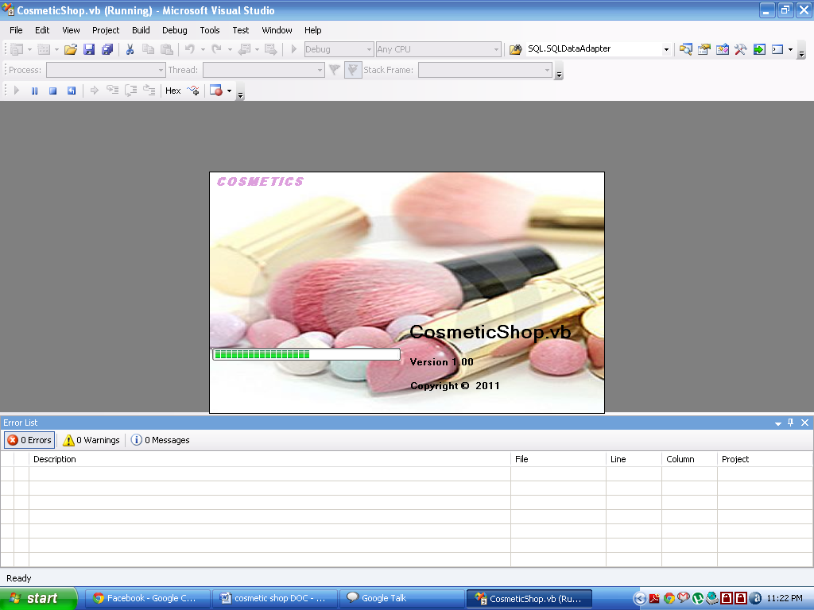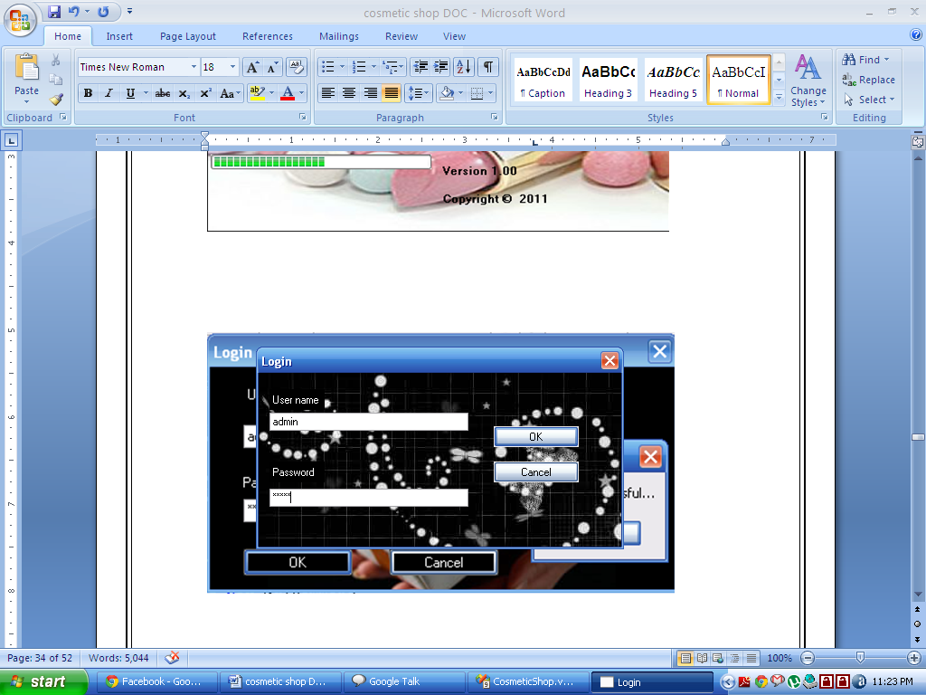

MDI Form :

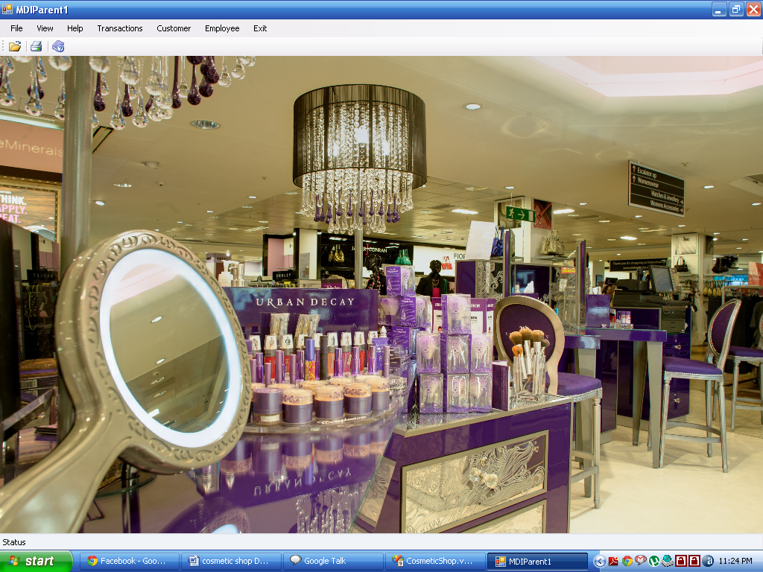

Supplier Details:

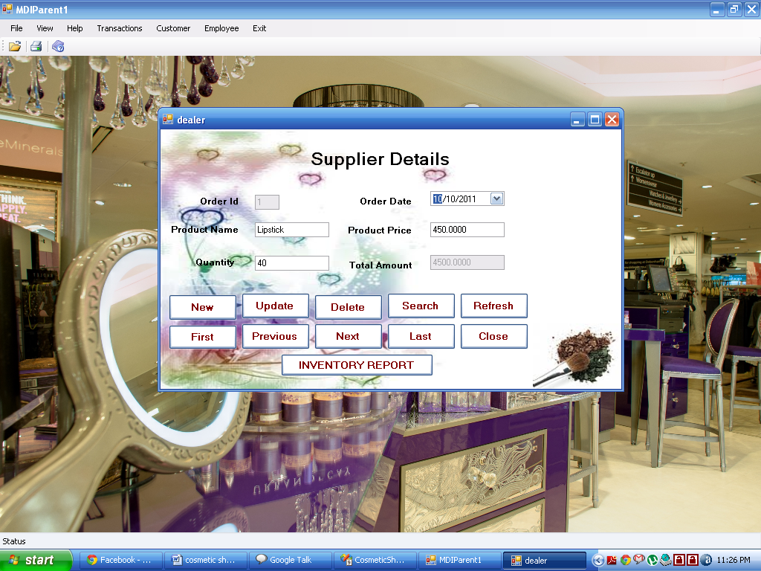

Profit :

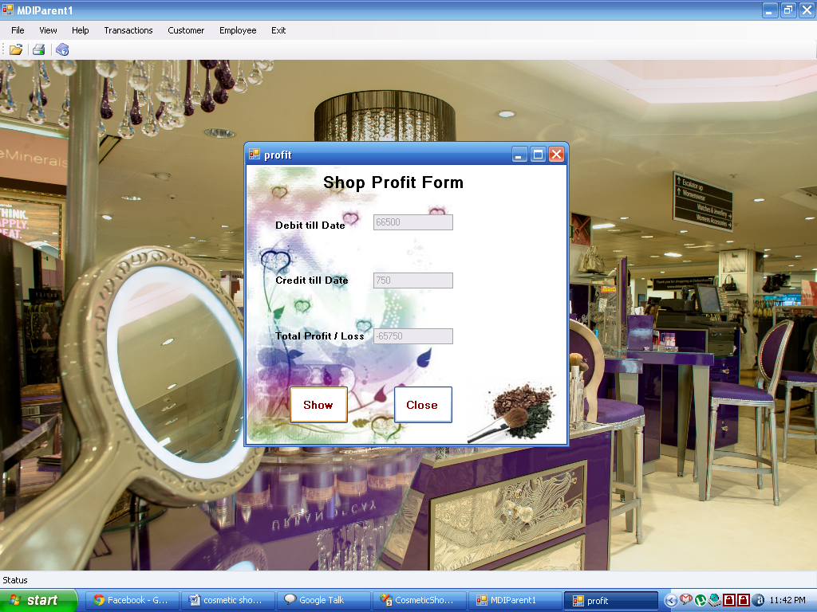

Customer Bill :

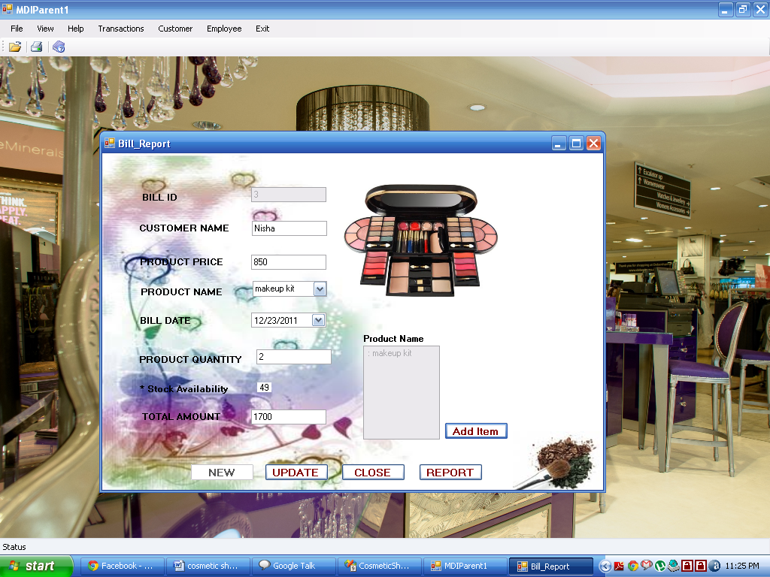

Customer Bill Details:

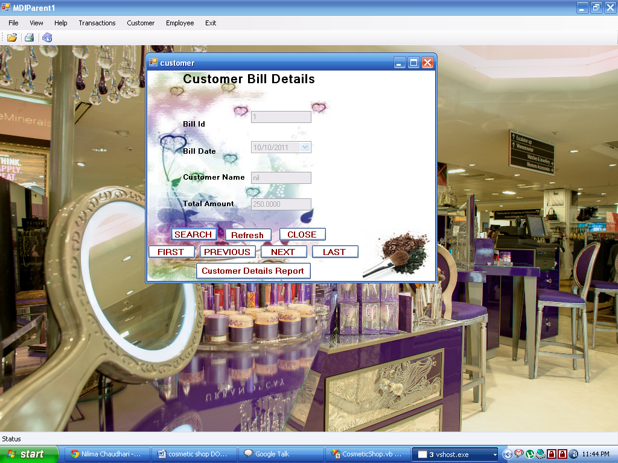

Employee Details :

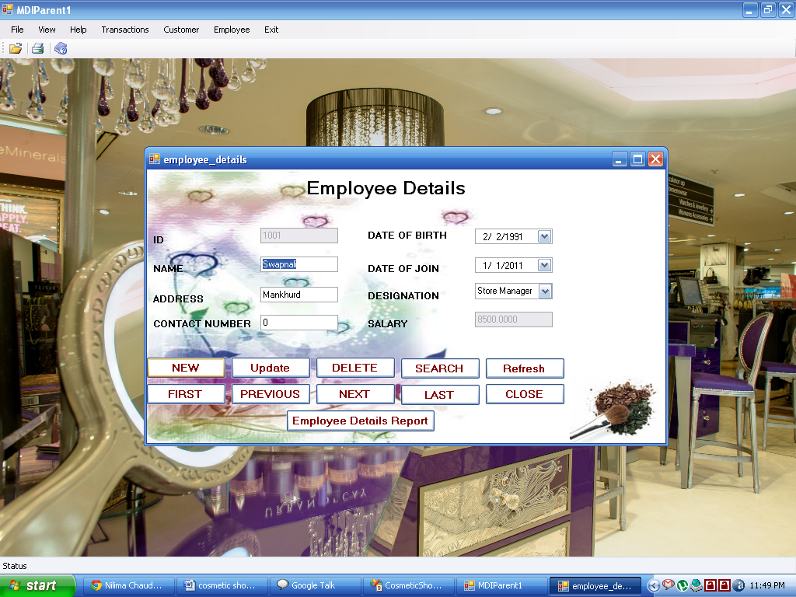

EMPSalary Slip:

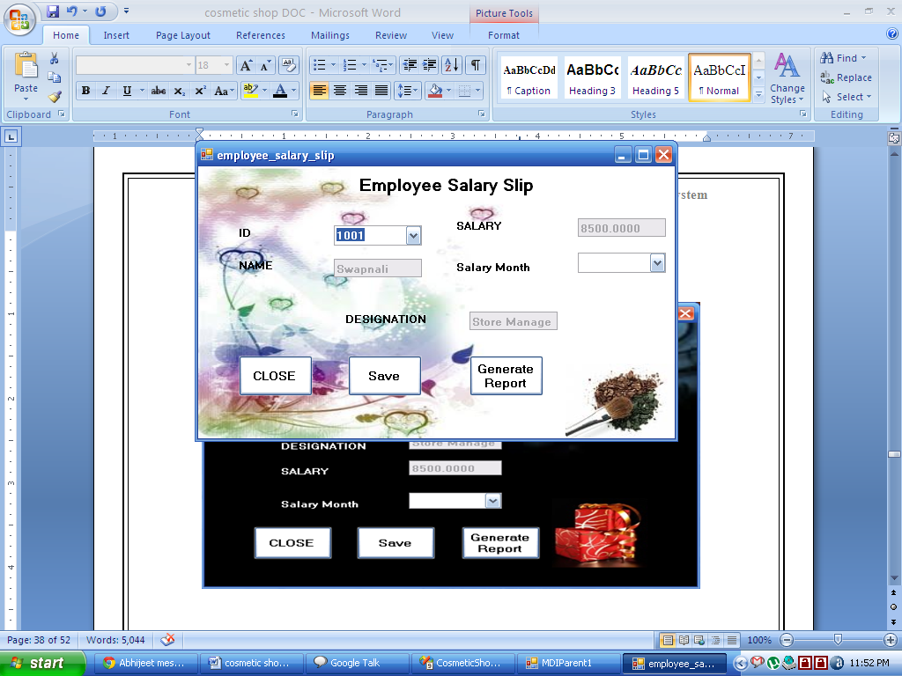

Dealer Report :

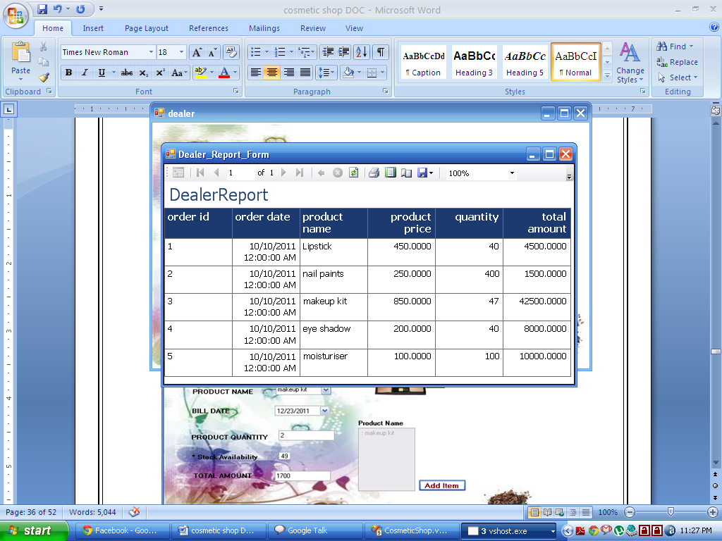

Customer Bill Report :

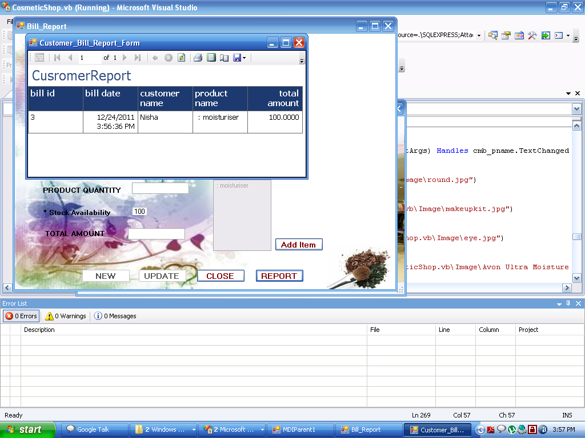

Customer Details Report :

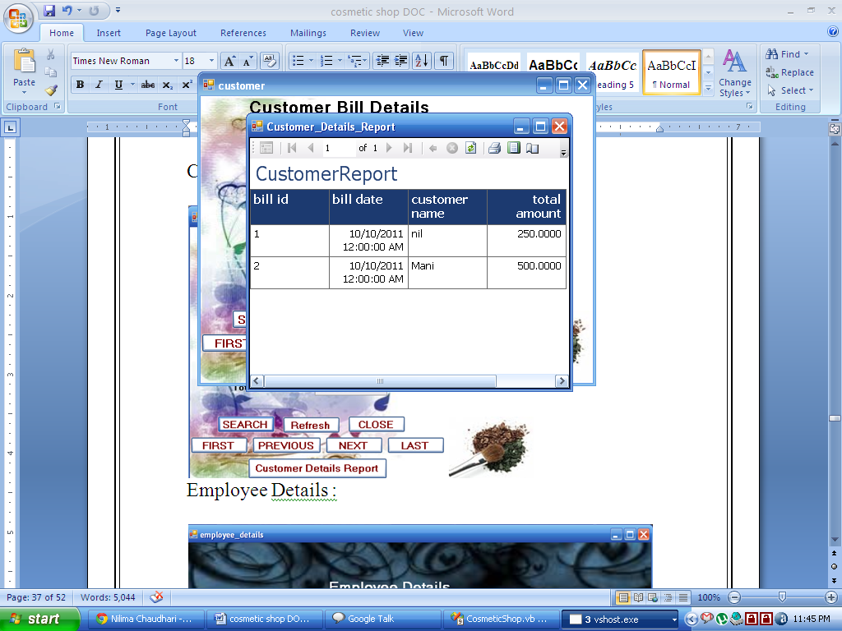

EMP Report :

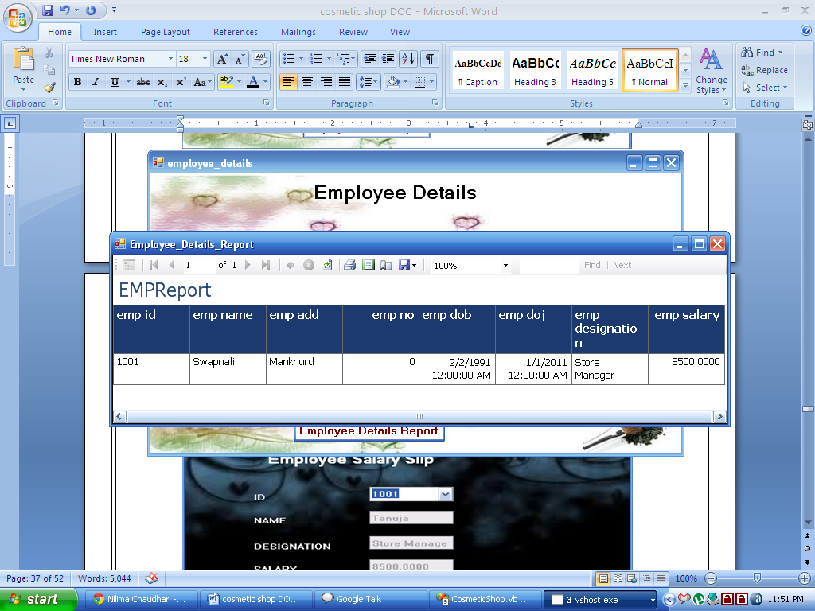

Salary Report :

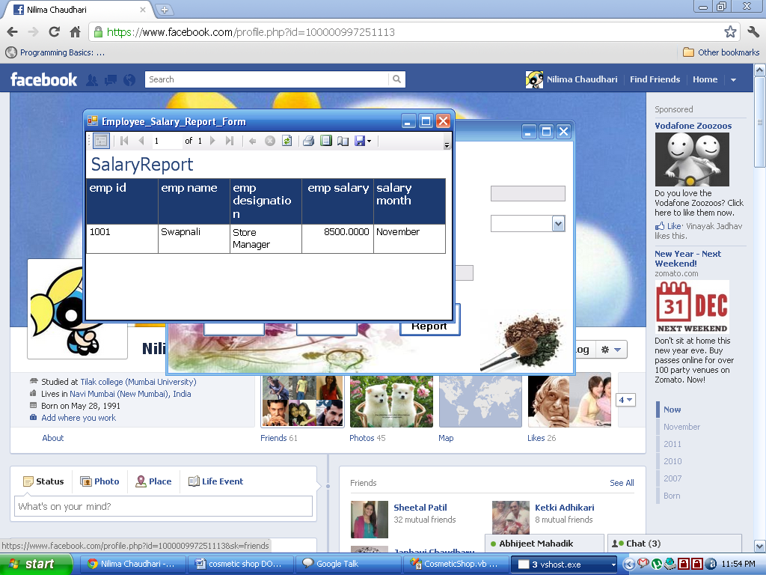

**Coding**

**Login Page :**

Imports System.Data.SqlClient

Public Class Login

Private Sub OK_Click(ByVal sender As System.Object, ByVal e As System.EventArgs) Handles OK.Click

Dim cmd As SqlCommand

Dim conn As SqlConnection

Dim sql = "SELECT username,password FROM Login WHERE username = '" & UsernameTextBox.Text & "' AND password = '" & PasswordTextBox.Text & "'"

conn = New SqlConnection("Data Source=.\SQLEXPRESS;AttachDbFilename=|DataDirectory|\Data\Cosmetic.mdf;Integrated Security=True;User Instance=True")

conn.Open()

cmd = New SqlCommand(sql, conn)

Dim dr As SqlDataReader = cmd.ExecuteReader

Try

If dr.Read = False Then

MessageBox.Show("Authentication Failed...")

Else

MessageBox.Show("Login Successful...")

MDIParent1.Show()

Me.Hide()

End If

Catch ex As Exception

MsgBox(ex.Message)

End Try

If conn.State <> ConnectionState.Closed Then

conn.Close()

End If

End Sub

Private Sub Cancel_Click(ByVal sender As System.Object, ByVal e As System.EventArgs) Handles Cancel.Click

Me.Close()

Application.Exit()

End Sub

End Class

**MDI Form :**

Imports System.Windows.Forms

Public Class MDIParent1

Private Sub ShowNewForm(ByVal sender As Object, ByVal e As EventArgs)

' Create a new instance of the child form.

Dim ChildForm As New System.Windows.Forms.Form

' Make it a child of this MDI form before showing it.

ChildForm.MdiParent = Me

m_ChildFormNumber += 1

ChildForm.Text = "Window " & m_ChildFormNumber

ChildForm.Show()

End Sub

Private Sub OpenFile(ByVal sender As Object, ByVal e As EventArgs) Handles OpenToolStripMenuItem.Click, OpenToolStripButton.Click

Dim OpenFileDialog As New OpenFileDialog

OpenFileDialog.InitialDirectory = My.Computer.FileSystem.SpecialDirectories.MyDocuments

OpenFileDialog.Filter = "Text Files (*.txt)|*.txt|All Files (*.*)|*.*"

If (OpenFileDialog.ShowDialog(Me) = System.Windows.Forms.DialogResult.OK) Then

Dim FileName As String = OpenFileDialog.FileName

' TODO: Add code here to open the file.

End If

End Sub

Private Sub SaveAsToolStripMenuItem_Click(ByVal sender As Object, ByVal e As EventArgs)

Dim SaveFileDialog As New SaveFileDialog

SaveFileDialog.InitialDirectory = My.Computer.FileSystem.SpecialDirectories.MyDocuments

SaveFileDialog.Filter = "Text Files (*.txt)|*.txt|All Files (*.*)|*.*"

If (SaveFileDialog.ShowDialog(Me) = System.Windows.Forms.DialogResult.OK) Then

Dim FileName As String = SaveFileDialog.FileName

' TODO: Add code here to save the current contents of the form to a file.

End If

End Sub

Private Sub ExitToolsStripMenuItem_Click(ByVal sender As Object, ByVal e As EventArgs) Handles ExitToolStripMenuItem.Click

Me.Close()

Application.Exit()

End Sub

Private Sub CopyToolStripMenuItem_Click(ByVal sender As Object, ByVal e As EventArgs)

End Sub

Private Sub PasteToolStripMenuItem_Click(ByVal sender As Object, ByVal e As EventArgs)

End Sub

Private Sub ToolBarToolStripMenuItem_Click(ByVal sender As Object, ByVal e As EventArgs) Handles ToolBarToolStripMenuItem.Click

Me.ToolStrip.Visible = Me.ToolBarToolStripMenuItem.Checked

End Sub

Private Sub StatusBarToolStripMenuItem_Click(ByVal sender As Object, ByVal e As EventArgs) Handles StatusBarToolStripMenuItem.Click

Me.StatusStrip.Visible = Me.StatusBarToolStripMenuItem.Checked

End Sub

Private Sub CascadeToolStripMenuItem_Click(ByVal sender As Object, ByVal e As EventArgs)

Me.LayoutMdi(MdiLayout.Cascade)

End Sub

Private Sub TileVerticalToolStripMenuItem_Click(ByVal sender As Object, ByVal e As EventArgs)

Me.LayoutMdi(MdiLayout.TileVertical)

End Sub

Private Sub TileHorizontalToolStripMenuItem_Click(ByVal sender As Object, ByVal e As EventArgs)

Me.LayoutMdi(MdiLayout.TileHorizontal)

End Sub

Private Sub ArrangeIconsToolStripMenuItem_Click(ByVal sender As Object, ByVal e As EventArgs)

Me.LayoutMdi(MdiLayout.ArrangeIcons)

End Sub

Private Sub CloseAllToolStripMenuItem_Click(ByVal sender As Object, ByVal e As EventArgs)

' Close all child forms of the parent.

For Each ChildForm As Form In Me.MdiChildren

ChildForm.Close()

Next

End Sub

Private m_ChildFormNumber As Integer

Private Sub CustomerReceiptToolStripMenuItem_Click(ByVal sender As System.Object, ByVal e As System.EventArgs) Handles CustomerReceiptToolStripMenuItem.Click

Bill_Report.Show()

End Sub

Private Sub ExitToolStripMenuItem1_Click(ByVal sender As System.Object, ByVal e As System.EventArgs) Handles ExitToolStripMenuItem1.Click

Application.Exit()

End Sub

Private Sub DetailsToolStripMenuItem_Click(ByVal sender As System.Object, ByVal e As System.EventArgs) Handles DetailsToolStripMenuItem.Click

employee_details.Show()

End Sub

Private Sub InventoryToolStripMenuItem_Click(ByVal sender As System.Object, ByVal e As System.EventArgs) Handles InventoryToolStripMenuItem.Click

dealer.Show()

End Sub

Private Sub UpdateStockToolStripMenuItem_Click(ByVal sender As System.Object, ByVal e As System.EventArgs) Handles UpdateStockToolStripMenuItem.Click

profit.Show()

End Sub

Private Sub EmployeSalarySlipToolStripMenuItem_Click(ByVal sender As System.Object, ByVal e As System.EventArgs) Handles EmployeSalarySlipToolStripMenuItem.Click

employee_salary_slip.Show()

End Sub

Private Sub CustomerDetailsToolStripMenuItem_Click(ByVal sender As System.Object, ByVal e As System.EventArgs) Handles CustomerDetailsToolStripMenuItem.Click

customer.Show()

End Sub

Private Sub AboutToolStripMenuItem_Click(ByVal sender As System.Object, ByVal e As System.EventArgs) Handles AboutToolStripMenuItem.Click

frmAbout.Show()

End Sub

Private Sub HelpToolStripButton_Click(ByVal sender As System.Object, ByVal e As System.EventArgs) Handles HelpToolStripButton.Click

frmAbout.Show()

End Sub

Private Sub PrintToolStripButton_Click(ByVal sender As System.Object, ByVal e As System.EventArgs) Handles PrintToolStripButton.Click

PrintDialog1.ShowDialog()

End Sub

Private Sub MDIParent1_Load(ByVal sender As System.Object, ByVal e As System.EventArgs) Handles MyBase.Load

End Sub

End Class

**Bill Report :**

Imports System.Data.SqlClient

Imports System.Data

'Imports CrystalDecisions.CrystalReports.Engine

Public Class Bill_Report

Dim cnnSQL As New SQLConnection

Dim cmdSQL As New SQLCommand

Dim cmdAdd As New SQLCommand

Dim cmdAdd1 As New SQLCommand

Dim cmdAdd2 As New SQLCommand

Dim cmdSave As New SQLCommand

Dim cmdDelete As New SQLCommand

Dim cmdNew As New SQLCommand

Dim avlq As Integer

Dim pid As String

Dim flag As Integer

Private BS As New BindingSource

Private Sub clear()

txt_billid.Text = ""

txt_cname.Text = ""

cmb_pname.Text = ""

txt_price.Text = ""

txt_qty.Text = ""

txt_amt.Text = ""

End Sub

Private Sub Bill_Report_Load(ByVal sender As System.Object, ByVal e As System.EventArgs) Handles MyBase.Load

cnnSQL = New SqlConnection("Data Source=.\SQLEXPRESS;AttachDbFilename=|DataDirectory|\Data\Cosmetic.mdf;Integrated Security=True;User Instance=True")

'provider to be used when working with access database

cnnSQL.Open()

Dim cmd = New SqlCommand("select product_name from dealer_order", cnnSQL)

Dim dr = cmd.ExecuteReader

While dr.Read()

cmb_pname.Items.Add(dr("product_name"))

End While

dr.Close()

cnnSQL.Close()

btnAdd.Enabled = True

btnSave.Enabled = False

btnReport.Enabled = True

End Sub

Public Sub onlyAlphabets(ByVal e As System.Windows.Forms.KeyPressEventArgs)

If Not Asc(e.KeyChar) = 8 Then

If InStr("abcdegfhijklmnopqrstuvwxyz", e.KeyChar, CompareMethod.Text) = 0 Then

e.Handled = True

End If

End If

End Sub

Private Sub txt_cname_keyPress(ByVal sender As Object, ByVal e As System.Windows.Forms.KeyPressEventArgs) Handles txt_cname.KeyPress

onlyAlphabets(e)

End Sub

Private Sub btnAdd_Click(ByVal sender As System.Object, ByVal e As System.EventArgs) Handles btnAdd.Click

cnnSQL = New SqlConnection("Data Source=.\SQLEXPRESS;AttachDbFilename=|DataDirectory|\Data\Cosmetic.mdf;Integrated Security=True;User Instance=True")

cnnSQL.Open()

Dim cmd As New SqlCommand("Select Max(bill_id) from customer", cnnSQL)

Dim maxrows As Integer = cmd.ExecuteScalar()

maxrows = maxrows + 1

txt_billid.Text = maxrows

'MsgBox(maxrows)

cmd = Nothing

cmdDelete.CommandText = "DELETE FROM bill_report;"

'MsgBox(cmdDelete.CommandText)

cmdDelete.CommandType = CommandType.Text

cmdDelete.Connection = cnnSQL

cmdDelete.ExecuteNonQuery()

btnAdd.Enabled = False

btnSave.Enabled = True

cnnSQL.Close()

End Sub

Private Sub txt_price_KeyPress(ByVal sender As Object, ByVal e As System.Windows.Forms.KeyPressEventArgs) Handles txt_price.KeyPress

If (Microsoft.VisualBasic.Asc(e.KeyChar) < 48) Or (Microsoft.VisualBasic.Asc(e.KeyChar) > 57) Then

e.Handled = True

End If

If (Microsoft.VisualBasic.Asc(e.KeyChar) = 8) Then

e.Handled = False

End If

End Sub

Private Sub txt_price_LostFocus(ByVal sender As Object, ByVal e As System.EventArgs) Handles txt_price.LostFocus

cnnSQL = New SqlConnection("Data Source=.\SQLEXPRESS;AttachDbFilename=|DataDirectory|\Data\Cosmetic.mdf;Integrated Security=True;User Instance=True")

'provider to be used when working with access database

cnnSQL.Open()

Dim cmd1 = New SqlCommand("select * from dealer_order where product_name = '" & cmb_pname.Text & "' ", cnnSQL)

Dim dr1 = cmd1.ExecuteReader

While dr1.Read()

lbl1.Text = dr1(4)

End While

dr1.Close()

cnnSQL.Close()

End Sub

Private Sub txt_qty_KeyPress(ByVal sender As Object, ByVal e As System.Windows.Forms.KeyPressEventArgs) Handles txt_qty.KeyPress

If (Microsoft.VisualBasic.Asc(e.KeyChar) < 48) Or (Microsoft.VisualBasic.Asc(e.KeyChar) > 57) Then

e.Handled = True

End If

If (Microsoft.VisualBasic.Asc(e.KeyChar) = 8) Then

e.Handled = False

End If

End Sub

Private Sub txt_qty_LostFocus(ByVal sender As System.Object, ByVal e As System.EventArgs) Handles txt_qty.LostFocus

End Sub

Private Sub btnSave_Click(ByVal sender As System.Object, ByVal e As System.EventArgs) Handles btnSave.Click

cnnSQL = New SqlConnection("Data Source=.\SQLEXPRESS;AttachDbFilename=|DataDirectory|\Data\Cosmetic.mdf;Integrated Security=True;User Instance=True")

cnnSQL.Open()

If txt_billid.Text = "" Or txt_cname.Text = "" Or cmb_pname.Text = "" Or txt_price.Text = "" Or txt_qty.Text = "" Or txt_amt.Text = "" Then

MsgBox("Please Provide All the Values")

Exit Sub

Me.Close()

End If

cmdAdd.CommandText = "INSERT INTO bill_report (bill_id, bill_date, customer_name, product_name, total_amount) VALUES ('" & txt_billid.Text & "','" & dtp_billdate.Value & "','" & txt_cname.Text & "','" & lb_pname.Text & "','" & txt_amt.Text & "');"

'MsgBox(cmdAdd.CommandText)

cmdAdd.CommandType = CommandType.Text

cmdAdd.Connection = cnnSQL

cmdAdd.ExecuteNonQuery()

cnnSQL.Close()

cnnSQL = New SqlConnection("Data Source=.\SQLEXPRESS;AttachDbFilename=|DataDirectory|\Data\Cosmetic.mdf;Integrated Security=True;User Instance=True")

cnnSQL.Open()

cmdAdd1.CommandText = "INSERT INTO customer (bill_id, bill_date, customer_name, total_amount) VALUES ('" & txt_billid.Text & "','" & dtp_billdate.Value & "','" & txt_cname.Text & "','" & txt_amt.Text & "');"

'MsgBox(cmdAdd.CommandText)

cmdAdd1.CommandType = CommandType.Text

cmdAdd1.Connection = cnnSQL

cmdAdd1.ExecuteNonQuery()

cnnSQL.Close()

cnnSQL = New SqlConnection("Data Source=.\SQLEXPRESS;AttachDbFilename=|DataDirectory|\Data\Cosmetic.mdf;Integrated Security=True;User Instance=True;")

cnnSQL.Open()

cmdAdd2.CommandText = "INSERT INTO credit (credit_date, credit_amount, credit_description) VALUES ('" & dtp_billdate.Value & "','" & txt_amt.Text & "','" & txt_cname.Text & "');"

cmdAdd2.CommandType = CommandType.Text

cmdAdd2.Connection = cnnSQL

cmdAdd2.ExecuteNonQuery()

cnnSQL.Close()

MsgBox("Record Inserted.")

btnSave.Enabled = False

btnReport.Enabled = True

End Sub

Private Sub btnClose_Click(ByVal sender As System.Object, ByVal e As System.EventArgs) Handles btnClose.Click

Me.Close()

End Sub

Private Sub btnReport_Click(ByVal sender As System.Object, ByVal e As System.EventArgs) Handles btnReport.Click

Customer_Bill_Report_Form.Show()

Call clear()

End Sub

Private Sub cmb_pname_TextChanged(ByVal sender As Object, ByVal e As System.EventArgs) Handles cmb_pname.TextChanged

If cmb_pname.Text = "nail paints" Then

PictureBox1.Image = Image.FromFile("H:\CosmeticShop.vb\CosmeticShop.vb\Image\round.jpg")

Else

If cmb_pname.Text = "makeup kit" Then

PictureBox1.Image = Image.FromFile("H:\CosmeticShop.vb\CosmeticShop.vb\Image\makeupkit.jpg")

Else

If cmb_pname.Text = "eye shadow" Then

PictureBox1.Image = Image.FromFile("H:\CosmeticShop.vb\CosmeticShop.vb\Image\eye.jpg")

Else

If cmb_pname.Text = "Lipstick" Then

PictureBox1.Image = Image.FromFile("H:\CosmeticShop.vb\CosmeticShop.vb\Image\Avon Ultra Moisture Rich 24K Gold lipstick.jpg")

Else

If cmb_pname.Text = "moisturiser" Then

PictureBox1.Image = Image.FromFile("H:\CosmeticShop.vb\CosmeticShop.vb\Image\moisturiser.jpg")

End If

End If

End If

End If

End If

End Sub

Private Sub btnAddItem_Click(ByVal sender As System.Object, ByVal e As System.EventArgs) Handles btnAddItem.Click

If Val(txt_qty.Text) > Val(lbl1.Text) Then

MsgBox("Please Select within the Available Quantity !!! ")

Exit Sub

Else

Dim q As Integer = Val(txt_qty.Text)

Dim p As Integer = Val(txt_price.Text)

Dim t As Integer = q * p

txt_amt.Text = Val(txt_amt.Text) + t

lblhide.Text = Val(lbl1.Text) - Val(txt_qty.Text)

cnnSQL = New SqlConnection("Data Source=.\SQLEXPRESS;AttachDbFilename=|DataDirectory|\Data\Cosmetic.mdf;Integrated Security=True;User Instance=True")

cnnSQL.Open()

cmdSave.CommandText = "UPDATE dealer_order SET quantity = '" & lbl1.Text & "' WHERE product_name = '" & cmb_pname.Text & "';"

cmdSave.CommandType = CommandType.Text

cmdSave.Connection = cnnSQL

cmdSave.ExecuteNonQuery()

lb_pname.Text = lb_pname.Text + " : " + cmb_pname.Text

End If

End Sub

Private Sub txt_cname_TextChanged(ByVal sender As System.Object, ByVal e As System.EventArgs) Handles txt_cname.TextChanged

End Sub

Private Sub Button1_Click(ByVal sender As System.Object, ByVal e As System.EventArgs)

Customer_Bill_Report_Form.Show()

End Sub

Private Sub cmb_pname_SelectedIndexChanged(ByVal sender As System.Object, ByVal e As System.EventArgs) Handles cmb_pname.SelectedIndexChanged

End Sub

End Class

**Customer :**

Imports System.Data.Sqlclient

Imports System.Data

Public Class customer

Dim cnnSQL As New SQLConnection

Dim cmdSQL As New SQLCommand

Dim cmdAdd As New SQLCommand

Dim cmdSave As New SQLCommand

Dim cmdDelete As New SQLCommand

Dim flag As Integer

Private BS As New BindingSource

Private Sub clear()

txt_id.Text = ""

txt_cname.Text = ""

txt_amt.Text = ""

End Sub

Private Sub customer_Load(ByVal sender As System.Object, ByVal e As System.EventArgs) Handles MyBase.Load

txt_id.Enabled = False

txt_cname.Enabled = False

txt_amt.Enabled = False

dtp_bill.Enabled = False

Dim ds As New DataSet

cnnSQL = New SqlConnection("Data Source=.\SQLEXPRESS;AttachDbFilename=|DataDirectory|\Data\Cosmetic.mdf;Integrated Security=True;User Instance=True")

cnnSQL.Open()

Call clear()

Dim Sql = "SELECT * FROM customer"

Dim da = New SqlDataAdapter(Sql, cnnSQL)

da.Fill(ds, "customer")

' Set the Binding Source

BS.DataSource = ds.Tables("customer")

txt_id.DataBindings.Add("Text", BS, "bill_id")

dtp_bill.DataBindings.Add("Text", BS, "bill_date")

txt_cname.DataBindings.Add("Text", BS, "customer_name")

txt_amt.DataBindings.Add("Text", BS, "total_amount")

End Sub

Private Sub btnPrevious_Click(ByVal sender As System.Object, ByVal e As System.EventArgs) Handles btnPrevious.Click

If BS.Count = 0 Then

MsgBox("Records are Empty")

End If

BS.MovePrevious()

flag = 1

End Sub

Private Sub btnNext_Click(ByVal sender As System.Object, ByVal e As System.EventArgs) Handles btnNext.Click

If BS.Count = 0 Then

MsgBox("Records are Empty")

End If

BS.MoveNext()

flag = 1

End Sub

Private Sub btnLast_Click(ByVal sender As System.Object, ByVal e As System.EventArgs) Handles btnLast.Click

If BS.Count = 0 Then

MsgBox("Records are Empty")

End If

BS.MoveLast()

flag = 1

End Sub

Private Sub btnFirst_Click(ByVal sender As System.Object, ByVal e As System.EventArgs) Handles btnFirst.Click

If BS.Count = 0 Then

MsgBox("Records are Empty")

End If

BS.MoveFirst()

flag = 1

End Sub

Private Sub btnClose_Click(ByVal sender As System.Object, ByVal e As System.EventArgs) Handles btnClose.Click

cnnSQL.Close()

Me.Hide()

Me.Close()

End Sub

Private Sub btnSearch_Click(ByVal sender As System.Object, ByVal e As System.EventArgs) Handles btnSearch.Click

Try

cnnSQL = New SqlConnection("Data Source=.\SQLEXPRESS;AttachDbFilename=|DataDirectory|\Data\Cosmetic.mdf;Integrated Security=True;User Instance=True")

'provider to be used when working with access database

cnnSQL.Open()

Dim vSearch As String = InputBox("Enter Bill ID number to search details:")

If vSearch <> "" Then

Dim cmd = New SqlCommand("select * from customer WHERE bill_id = '" & CInt(vSearch) & "' ", cnnSQL)

cmd.Connection = cnnSQL

Dim dr As SqlDataReader = cmd.ExecuteReader

If dr.Read = True Then

txt_id.Text = dr(0)

dtp_bill.Value = dr(1)

txt_cname.Text = dr(2)

txt_amt.Text = dr(3)

' loading data into TextBoxes by column index

dr.Close()

Else

MsgBox("Record not found")

End If

Else

MsgBox("Enter search value.")

End If

Catch

End Try

btnSearch.Enabled = False

btnFirst.Enabled = False

btnPrevious.Enabled = False

btnNext.Enabled = False

btnLast.Enabled = False

End Sub

Private Sub btnRefresh_Click(ByVal sender As System.Object, ByVal e As System.EventArgs) Handles btnRefresh.Click

Dim ds As New DataSet

' Make the Connection

cnnSQL = New SqlConnection("Data Source=.\SQLEXPRESS;AttachDbFilename=|DataDirectory|\Data\Cosmetic.mdf;Integrated Security=True;User Instance=True")

cnnSQL.Open()

Call clear()

Dim Sql = "SELECT * FROM customer"

Dim da = New SqlDataAdapter(Sql, cnnSQL)

da.Fill(ds, "customer")

' Set the Binding Source

BS.DataSource = ds.Tables("customer")

btnSearch.Enabled = True

btnFirst.Enabled = True

btnPrevious.Enabled = True

btnNext.Enabled = True

btnLast.Enabled = True

End Sub

Private Sub btnReport_Click(ByVal sender As System.Object, ByVal e As System.EventArgs) Handles btnReport.Click

Customer_Details_Report.Show()

End Sub

End Class

**Dealer :**

Imports System.Data.Sqlclient

Imports System.Data

Public Class dealer

Dim cnnSQL As New SQLConnection

Dim cmdSQL As New SQLCommand

Dim cmdAdd As New SQLCommand

Dim cmdAdd1 As New SQLCommand

Dim cmdSave As New SQLCommand

Dim cmdDelete As New SQLCommand

Dim flag As Integer

Private BS As New BindingSource

Private Sub clear()

txt_id.Text = ""

txt_pname.Text = ""

txt_price.Text = ""

txt_qty.Text = ""

txt_amt.Text = ""

End Sub

Private Sub btnAdd_Click(ByVal sender As System.Object, ByVal e As System.EventArgs) Handles btnAdd.Click

cnnSQL = New SqlConnection("Data Source=.\SQLEXPRESS;AttachDbFilename=|DataDirectory|\Data\Cosmetic.mdf;Integrated Security=True;User Instance=True")

cnnSQL.Open()

Call clear()

Dim cmd As New SqlCommand("Select Max(order_id) from dealer_order", cnnSQL)

Dim maxrows As Integer = cmd.ExecuteScalar()

maxrows = maxrows + 1

txt_id.Text = maxrows

'MsgBox(maxrows)

cmd = Nothing

flag = 2

btnSave.Text = "Update"

btnAdd.Enabled = False

btnDelete.Enabled = False

btnSearch.Enabled = False

btnFirst.Enabled = False

btnPrevious.Enabled = False

btnNext.Enabled = False

btnLast.Enabled = False

End Sub

Private Sub dealer_Load(ByVal sender As System.Object, ByVal e As System.EventArgs) Handles MyBase.Load

Dim ds As New DataSet

' Make the Connection

cnnSQL = New SqlConnection("Data Source=.\SQLEXPRESS;AttachDbFilename=|DataDirectory|\Data\Cosmetic.mdf;Integrated Security=True;User Instance=True")

cnnSQL.Open()

Call clear()

flag = 1

btnSave.Text = "Update"

Dim Sql = "SELECT * FROM dealer_order"

Dim da = New SqlDataAdapter(Sql, cnnSQL)

da.Fill(ds, "dealer_order")

' Set the Binding Source

BS.DataSource = ds.Tables("dealer_order")

txt_id.DataBindings.Add("Text", BS, "order_id")

dtp_order.DataBindings.Add("Text", BS, "order_date")

txt_pname.DataBindings.Add("Text", BS, "product_name")

txt_price.DataBindings.Add("Text", BS, "product_price")

txt_qty.DataBindings.Add("Text", BS, "quantity")

txt_amt.DataBindings.Add("Text", BS, "total_amount")

End Sub

Private Sub btnSave_Click(ByVal sender As System.Object, ByVal e As System.EventArgs) Handles btnSave.Click

If txt_id.Text = "" Or txt_pname.Text = "" Or txt_price.Text = "" Or txt_qty.Text = "" Or txt_amt.Text = "" Then

MsgBox("Please Provide All the Values")

Exit Sub

Me.Close()

End If

If flag = 2 Then

cmdAdd.CommandText = "INSERT INTO dealer_order (order_id, order_date, product_name, product_price, quantity, total_amount) VALUES ('" & txt_id.Text & "','" & dtp_order.Value & "','" & txt_pname.Text & "','" & txt_price.Text & "','" & txt_qty.Text & "','" & txt_amt.Text & "');"

'MsgBox(cmdAdd.CommandText)

cmdAdd.CommandType = CommandType.Text

cmdAdd.Connection = cnnSQL

cmdAdd.ExecuteNonQuery()

cmdAdd1.CommandText = "INSERT INTO debit (debit_date, debit_amount, debit_description) VALUES ('" & dtp_order.Value & "','" & txt_amt.Text & "','" & txt_pname.Text & "');"

'MsgBox(cmdAdd.CommandText)

cmdAdd1.CommandType = CommandType.Text

cmdAdd1.Connection = cnnSQL

cmdAdd1.ExecuteNonQuery()

MsgBox("Record Inserted.")

Call clear()

btnSave.Text = "Update"

btnAdd.Enabled = True

btnDelete.Enabled = True

btnSearch.Enabled = True

btnFirst.Enabled = True

btnPrevious.Enabled = True

btnNext.Enabled = True

btnLast.Enabled = True

Dim ds As New DataSet

' Make the Connection

cnnSQL = New SqlConnection("Data Source=.\SQLEXPRESS;AttachDbFilename=|DataDirectory|\Data\Cosmetic.mdf;Integrated Security=True;User Instance=True")

cnnSQL.Open()

Call clear()

btnSave.Text = "Update"

Dim Sql = "SELECT * FROM dealer_order"

Dim da = New SqlDataAdapter(Sql, cnnSQL)

da.Fill(ds, "dealer_order")

' Set the Binding Source

BS.DataSource = ds.Tables("dealer_order")

End If

If flag = 1 Then

cmdSave.CommandText = "UPDATE dealer_order SET order_date = '" & dtp_order.Value & "', product_name='" & txt_pname.Text & "', product_price='" & txt_price.Text & "', quantity='" & txt_qty.Text & "', total_amount='" & txt_amt.Text & "' WHERE order_id = '" & txt_id.Text & "';"

'MsgBox(cmdSave.CommandText)

cmdSave.CommandType = CommandType.Text

cmdSave.Connection = cnnSQL

cmdSave.ExecuteNonQuery()

MsgBox("Record Updated.")

Call clear()

Dim ds As New DataSet

' Make the Connection

cnnSQL = New SqlConnection("Data Source=.\SQLEXPRESS;AttachDbFilename=|DataDirectory|\Data\Cosmetic.mdf;Integrated Security=True;User Instance=True")

cnnSQL.Open()

Call clear()

flag = 1

btnSave.Text = "Update"

Dim Sql = "SELECT * FROM dealer_order"

Dim da = New SqlDataAdapter(Sql, cnnSQL)

da.Fill(ds, "dealer_order")

' Set the Binding Source

BS.DataSource = ds.Tables("dealer_order")

End If

cmdSave.Dispose()

cmdAdd.Dispose()

End Sub

Private Sub btnPrevious_Click(ByVal sender As System.Object, ByVal e As System.EventArgs) Handles btnPrevious.Click

If BS.Count = 0 Then

MsgBox("Records are Empty")

End If

BS.MovePrevious()

flag = 1

End Sub

Private Sub btnNext_Click(ByVal sender As System.Object, ByVal e As System.EventArgs) Handles btnNext.Click

If BS.Count = 0 Then

MsgBox("Records are Empty")

End If

BS.MoveNext()

flag = 1

End Sub

Private Sub btnLast_Click(ByVal sender As System.Object, ByVal e As System.EventArgs) Handles btnLast.Click

If BS.Count = 0 Then

MsgBox("Records are Empty")

End If

BS.MoveLast()

flag = 1

End Sub

Private Sub btnFirst_Click(ByVal sender As System.Object, ByVal e As System.EventArgs) Handles btnFirst.Click

If BS.Count = 0 Then

MsgBox("Records are Empty")

End If

BS.MoveFirst()

flag = 1

End Sub

Private Sub btnClose_Click(ByVal sender As System.Object, ByVal e As System.EventArgs) Handles btnClose.Click

cnnSQL.Close()

Me.Hide()

Me.Close()

End Sub

Private Sub btnDelete_Click(ByVal sender As System.Object, ByVal e As System.EventArgs) Handles btnDelete.Click

If txt_id.Text <> "" Then

cmdDelete.CommandText = "DELETE FROM dealer_order WHERE order_id = '" & txt_id.Text & "';"

'MsgBox(cmdDelete.CommandText)

cmdDelete.CommandType = CommandType.Text

cmdDelete.Connection = cnnSQL

cmdDelete.ExecuteNonQuery()

MsgBox("Record deleted.")

Call clear()

Dim ds As New DataSet

' Make the Connection

cnnSQL = New SqlConnection("Data Source=.\SQLEXPRESS;AttachDbFilename=|DataDirectory|\Data\Cosmetic.mdf;Integrated Security=True;User Instance=True")

cnnSQL.Open()

Call clear()

flag = 1

btnSave.Text = "Update"

Dim Sql = "SELECT * FROM dealer_order"

Dim da = New SqlDataAdapter(Sql, cnnSQL)

da.Fill(ds, "dealer_order")

' Set the Binding Source

BS.DataSource = ds.Tables("dealer_order")

cmdDelete.Dispose()

Else

MsgBox("Enter the required values:" & vbNewLine & "1. Order ID")

End If

cmdSave.Dispose()

End Sub

Private Sub btnSearch_Click(ByVal sender As System.Object, ByVal e As System.EventArgs) Handles btnSearch.Click

Try

cnnSQL = New SqlConnection("Data Source=.\SQLEXPRESS;AttachDbFilename=|DataDirectory|\Data\Cosmetic.mdf;Integrated Security=True;User Instance=True")

'provider to be used when working with access database

cnnSQL.Open()

Dim vSearch As String = InputBox("Enter Order ID number to search details:")

If vSearch <> "" Then

Dim cmd = New SqlCommand("select * from dealer_order WHERE order_id = '" & CInt(vSearch) & "' ", cnnSQL)

cmd.Connection = cnnSQL

Dim dr As SqlDataReader = cmd.ExecuteReader

If dr.Read = True Then

txt_id.Text = dr(0)

dtp_order.Value = dr(1)

txt_pname.Text = dr(2)

txt_price.Text = dr(3)

txt_qty.Text = dr(4)

txt_amt.Text = dr(5)

' loading data into TextBoxes by column index

dr.Close()

Else

MsgBox("Record not found")

End If

Else

MsgBox("Enter search value.")

End If

Catch

End Try

btnSave.Enabled = False

btnAdd.Enabled = False

btnDelete.Enabled = False

btnSearch.Enabled = False

btnFirst.Enabled = False

btnPrevious.Enabled = False

btnNext.Enabled = False

btnLast.Enabled = False

End Sub

Private Sub btnRefresh_Click(ByVal sender As System.Object, ByVal e As System.EventArgs) Handles btnRefresh.Click

Dim ds As New DataSet

' Make the Connection

cnnSQL = New SqlConnection("Data Source=.\SQLEXPRESS;AttachDbFilename=|DataDirectory|\Data\Cosmetic.mdf;Integrated Security=True;User Instance=True")

cnnSQL.Open()

Call clear()

flag = 1

btnSave.Text = "Update"

Dim Sql = "SELECT * FROM dealer_order"

Dim da = New SqlDataAdapter(Sql, cnnSQL)

da.Fill(ds, "dealer_order")

' Set the Binding Source

BS.DataSource = ds.Tables("dealer_order")

btnSave.Enabled = True

btnAdd.Enabled = True

btnDelete.Enabled = True

btnSearch.Enabled = True

btnFirst.Enabled = True

btnPrevious.Enabled = True

btnNext.Enabled = True

btnLast.Enabled = True

End Sub

Private Sub txt_qty_KeyPress(ByVal sender As Object, ByVal e As System.Windows.Forms.KeyPressEventArgs) Handles txt_qty.KeyPress

If (Microsoft.VisualBasic.Asc(e.KeyChar) < 48) Or (Microsoft.VisualBasic.Asc(e.KeyChar) > 57) Then

e.Handled = True

End If

If (Microsoft.VisualBasic.Asc(e.KeyChar) = 8) Then

e.Handled = False

End If

End Sub

Private Sub txt_qty_LostFocus(ByVal sender As Object, ByVal e As System.EventArgs) Handles txt_qty.LostFocus

Dim p As Integer = Val(txt_price.Text)

Dim q As Integer = Val(txt_qty.Text)

Dim t As Integer = p * q

txt_amt.Text = t

End Sub

Private Sub txt_price_KeyPress(ByVal sender As Object, ByVal e As System.Windows.Forms.KeyPressEventArgs) Handles txt_price.KeyPress

If (Microsoft.VisualBasic.Asc(e.KeyChar) < 48) Or (Microsoft.VisualBasic.Asc(e.KeyChar) > 57) Then

e.Handled = True

End If

If (Microsoft.VisualBasic.Asc(e.KeyChar) = 8) Then

e.Handled = False

End If

End Sub

Private Sub btnReport_Click(ByVal sender As System.Object, ByVal e As System.EventArgs) Handles btnReport.Click

Dealer_Report_Form.Show()

End Sub

End Class

**Employee Details :**

Imports System.Data.Sqlclient

Imports System.Data

Public Class employee_details

Dim cnnSQL As New SQLConnection

Dim cmdSQL As New SQLCommand

Dim cmdAdd As New SQLCommand

Dim cmdSave As New SQLCommand

Dim cmdDelete As New SQLCommand

Dim flag As Integer

Private BS As New BindingSource

Private Sub clear()

txt_id.Text = ""

txt_name.Text = ""

txt_add.Text = ""

txt_no.Text = ""

cmb_designation.Text = ""

txt_salary.Text = ""

End Sub

Private Sub employee_details_Load(ByVal sender As System.Object, ByVal e As System.EventArgs) Handles MyBase.Load

Dim ds As New DataSet

' Make the Connection

cnnSQL = New SqlConnection("Data Source=.\SQLEXPRESS;AttachDbFilename=|DataDirectory|\Data\Cosmetic.mdf;Integrated Security=True;User Instance=True")

cnnSQL.Open()

Call clear()

flag = 1

btnSave.Text = "Update"

Dim Sql = "SELECT * FROM employee_details"

Dim da = New SqlDataAdapter(Sql, cnnSQL)

da.Fill(ds, "employee_details")

' Set the Binding Source

BS.DataSource = ds.Tables("employee_details")

txt_id.DataBindings.Add("Text", BS, "emp_id")

txt_name.DataBindings.Add("Text", BS, "emp_name")

txt_add.DataBindings.Add("Text", BS, "emp_add")

txt_no.DataBindings.Add("Text", BS, "emp_no")

dtp_dob.DataBindings.Add("Text", BS, "emp_dob")

dtp_doj.DataBindings.Add("Text", BS, "emp_doj")

cmb_designation.DataBindings.Add("Text", BS, "emp_designation")

txt_salary.DataBindings.Add("Text", BS, "emp_salary")

End Sub

Private Sub btnNew_Click(ByVal sender As System.Object, ByVal e As System.EventArgs) Handles btnNew.Click

cnnSQL = New SqlConnection("Data Source=.\SQLEXPRESS;AttachDbFilename=|DataDirectory|\Data\Cosmetic.mdf;Integrated Security=True;User Instance=True")

cnnSQL.Open()

Call clear()

Dim cmd As New SqlCommand("Select Max(emp_id) from employee_details", cnnSQL)

Dim maxrows As Integer = cmd.ExecuteScalar()

maxrows = maxrows + 1

txt_id.Text = maxrows

'MsgBox(maxrows)C:\Documents and Settings\user\Desktop\CosmeticShop.vb\cosmetic.mdb

cmd = Nothing

flag = 2

btnSave.Text = "Save"

btnNew.Enabled = False

btnDelete.Enabled = False

btnSearch.Enabled = False

btnFirst.Enabled = False

btnPrevious.Enabled = False

btnNext.Enabled = False

btnLast.Enabled = False

End Sub

Private Sub btnSave_Click(ByVal sender As System.Object, ByVal e As System.EventArgs) Handles btnSave.Click

If txt_id.Text = "" Or txt_name.Text = "" Or txt_add.Text = "" Or txt_no.Text = "" Or cmb_designation.Text = "" Or txt_salary.Text = "" Then

MsgBox("Please Provide All the Values")

Exit Sub

Me.Close()

End If

If flag = 2 Then

If txt_id.Text <> "" And txt_name.Text <> "" And txt_add.Text <> "" And txt_no.Text <> "" And cmb_designation.Text <> "" And txt_salary.Text <> "" Then

cmdAdd.CommandText = "INSERT INTO employee_details (emp_id, emp_name, emp_add, emp_no, emp_dob, emp_doj, emp_designation, emp_salary) VALUES ('" & txt_id.Text & "','" & txt_name.Text & "','" & txt_add.Text & "','" & txt_no.Text & "','" & dtp_dob.Value & "','" & dtp_doj.Value & "','" & cmb_designation.Text & "','" & txt_salary.Text & "');"

'MsgBox(cmdAdd.CommandText)

cmdAdd.CommandType = CommandType.Text

cmdAdd.Connection = cnnSQL

cmdAdd.ExecuteNonQuery()

MsgBox("Record Inserted.")

Call clear()

btnSave.Text = "Update"

btnNew.Enabled = True

btnDelete.Enabled = True

btnSearch.Enabled = True

btnFirst.Enabled = True

btnPrevious.Enabled = True

btnNext.Enabled = True

btnLast.Enabled = True

Dim ds As New DataSet

' Make the Connection

cnnSQL = New SqlConnection("Data Source=.\SQLEXPRESS;AttachDbFilename=|DataDirectory|\Data\Cosmetic.mdf;Integrated Security=True;User Instance=True")

cnnSQL.Open()

Call clear()

btnSave.Text = "Update"

Dim Sql = "SELECT * FROM employee_details"

Dim da = New SqlDataAdapter(Sql, cnnSQL)

da.Fill(ds, "employee_details")

' Set the Binding Source

BS.DataSource = ds.Tables("employee_details")

End If

End If

If flag = 1 Then

If txt_id.Text <> "" And txt_name.Text <> "" And txt_add.Text <> "" And txt_no.Text <> "" And cmb_designation.Text <> "" And txt_salary.Text <> "" Then

cmdSave.CommandText = "UPDATE employee_details SET emp_name = '" & txt_name.Text & "', emp_add='" & txt_add.Text & "', emp_no='" & txt_no.Text & "', emp_dob='" & dtp_dob.Value & "', emp_doj='" & dtp_doj.Value & "', emp_designation='" & cmb_designation.Text & "', emp_salary='" & txt_salary.Text & "' WHERE emp_id = '" & txt_id.Text & "';"

'MsgBox(cmdSave.CommandText)

cmdSave.CommandType = CommandType.Text

cmdSave.Connection = cnnSQL

cmdSave.ExecuteNonQuery()

MsgBox("Record Updated.")

Call clear()

Dim ds As New DataSet

' Make the Connection

cnnSQL = New SqlConnection("Data Source=.\SQLEXPRESS;AttachDbFilename=|DataDirectory|\Data\Cosmetic.mdf;Integrated Security=True;User Instance=True")

cnnSQL.Open()

Call clear()

flag = 1

btnSave.Text = "Update"

Dim Sql = "SELECT * FROM employee_details"

Dim da = New SqlDataAdapter(Sql, cnnSQL)

da.Fill(ds, "employee_details")

' Set the Binding Source

BS.DataSource = ds.Tables("employee_details")

End If

End If

cmdSave.Dispose()

cmdAdd.Dispose()

End Sub

Private Sub btnPrevious_Click(ByVal sender As System.Object, ByVal e As System.EventArgs) Handles btnPrevious.Click

If BS.Count = 0 Then

MsgBox("Records are Empty")

End If

BS.MovePrevious()

flag = 1

End Sub

Private Sub btnNext_Click(ByVal sender As System.Object, ByVal e As System.EventArgs) Handles btnNext.Click

If BS.Count = 0 Then

MsgBox("Records are Empty")

End If

BS.MoveNext()

flag = 1

End Sub

Private Sub btnLast_Click(ByVal sender As System.Object, ByVal e As System.EventArgs) Handles btnLast.Click

If BS.Count = 0 Then

MsgBox("Records are Empty")

End If

BS.MoveLast()

flag = 1

End Sub

Private Sub btnFirst_Click(ByVal sender As System.Object, ByVal e As System.EventArgs) Handles btnFirst.Click

If BS.Count = 0 Then

MsgBox("Records are Empty")

End If

BS.MoveFirst()

flag = 1

End Sub

Private Sub btnClose_Click(ByVal sender As System.Object, ByVal e As System.EventArgs) Handles btnClose.Click

cnnSQL.Close()

Me.Hide()

Me.Close()

End Sub

Private Sub btnDelete_Click(ByVal sender As System.Object, ByVal e As System.EventArgs) Handles btnDelete.Click

If txt_id.Text <> "" Then

cmdDelete.CommandText = "DELETE FROM employee_details WHERE emp_id = '" & txt_id.Text & "';"

'MsgBox(cmdDelete.CommandText)

cmdDelete.CommandType = CommandType.Text

cmdDelete.Connection = cnnSQL

cmdDelete.ExecuteNonQuery()

MsgBox("Record deleted.")

Call clear()

Dim ds As New DataSet

' Make the Connection

cnnSQL = New SqlConnection("Data Source=.\SQLEXPRESS;AttachDbFilename=|DataDirectory|\Data\Cosmetic.mdf;Integrated Security=True;User Instance=True")

cnnSQL.Open()

Call clear()

flag = 1

btnSave.Text = "Update"

Dim Sql = "SELECT * FROM employee_details"

Dim da = New SqlDataAdapter(Sql, cnnSQL)

da.Fill(ds, "employee_details")

' Set the Binding Source

BS.DataSource = ds.Tables("employee_details")

cmdDelete.Dispose()

Else

MsgBox("Enter the required values:" & vbNewLine & "1. Employee ID")

End If

cmdSave.Dispose()

End Sub

Private Sub btnSearch_Click(ByVal sender As System.Object, ByVal e As System.EventArgs) Handles btnSearch.Click

Try

cnnSQL = New SqlConnection("Data Source=.\SQLEXPRESS;AttachDbFilename=|DataDirectory|\Data\Cosmetic.mdf;Integrated Security=True;User Instance=True")

'provider to be used when working with access database

cnnSQL.Open()

Dim vSearch As String = InputBox("Enter Employee ID number to search details:")

If vSearch <> "" Then

Dim cmd = New SqlCommand("select * from employee_details WHERE emp_id = '" & CInt(vSearch) & "' ", cnnSQL)

cmd.Connection = cnnSQL

Dim dr As SqlDataReader = cmd.ExecuteReader

If dr.Read = True Then

txt_id.Text = dr(0)

txt_name.Text = dr(1)

txt_add.Text = dr(2)

txt_no.Text = dr(3)

dtp_dob.Value = dr(4)

dtp_doj.Value = dr(5)

cmb_designation.Text = dr(6)

txt_salary.Text = dr(7)

' loading data into TextBoxes by column index

dr.Close()

Else

MsgBox("Record not found")

End If

Else

MsgBox("Enter search value.")

End If

Catch

End Try

btnSave.Enabled = False

btnNew.Enabled = False

btnDelete.Enabled = False

btnSearch.Enabled = False

btnFirst.Enabled = False

btnPrevious.Enabled = False

btnNext.Enabled = False

btnLast.Enabled = False

End Sub

Private Sub cmb_designation_TextChanged(ByVal sender As Object, ByVal e As System.EventArgs) Handles cmb_designation.TextChanged

If cmb_designation.Text = "Store Manager" Then

txt_salary.Text = "8500"

Else

If cmb_designation.Text = "Sales Boy" Then

txt_salary.Text = "7000"

Else

If cmb_designation.Text = "receptionist" Then

txt_salary.Text = "3000"

End If

End If

End If

End Sub

Private Sub btnRefresh_Click(ByVal sender As System.Object, ByVal e As System.EventArgs) Handles btnRefresh.Click

Dim ds As New DataSet

' Make the Connection

cnnSQL = New SqlConnection("Data Source=.\SQLEXPRESS;AttachDbFilename=|DataDirectory|\Data\Cosmetic.mdf;Integrated Security=True;User Instance=True")

cnnSQL.Open()

Call clear()

flag = 1

btnSave.Text = "Update"

Dim Sql = "SELECT * FROM employee_details"

Dim da = New SqlDataAdapter(Sql, cnnSQL)

da.Fill(ds, "employee_details")

' Set the Binding Source

BS.DataSource = ds.Tables("employee_details")

btnSave.Enabled = True

btnNew.Enabled = True

btnDelete.Enabled = True

btnSearch.Enabled = True

btnFirst.Enabled = True

btnPrevious.Enabled = True

btnNext.Enabled = True

btnLast.Enabled = True

End Sub

Private Sub txt_no_KeyPress(ByVal sender As Object, ByVal e As System.Windows.Forms.KeyPressEventArgs) Handles txt_no.KeyPress

If (Microsoft.VisualBasic.Asc(e.KeyChar) < 48) Or (Microsoft.VisualBasic.Asc(e.KeyChar) > 57) Then

e.Handled = True

End If

If (Microsoft.VisualBasic.Asc(e.KeyChar) = 8) Then

e.Handled = False

End If

End Sub

Private Sub btnReport_Click(ByVal sender As System.Object, ByVal e As System.EventArgs) Handles btnReport.Click

Employee_Details_Report.Show()

End Sub

End Class

**Employee Salary Slip :**

Imports System.Data.Sqlclient

Imports System.Data.Sqlclient.SQLException

'Imports CrystalDecisions.CrystalReports.Engine

Imports System.Data

Public Class employee_salary_slip

Dim cnnSQL As New SQLConnection

Dim cmdSQL As New SQLCommand

Dim cmdAdd As New SQLCommand

Dim cmdAdd1 As New SQLCommand

Private BS As New BindingSource

Private Sub clear()

cmb_id.Text = ""

cmb_month.Text = ""

txt_designation.Text = ""

txt_name.Text = ""

txt_salary.Text = ""

End Sub

Private Sub employee_salary_slip_Load(ByVal sender As System.Object, ByVal e As System.EventArgs) Handles MyBase.Load

cnnSQL = New SqlConnection("Data Source=.\SQLEXPRESS;AttachDbFilename=|DataDirectory|\Data\Cosmetic.mdf;Integrated Security=True;User Instance=True")

'provider to be used when working with access database

cnnSQL.Open()

Dim cmd = New SQLCommand("select emp_id from employee_details", cnnSQL)

Dim dr = cmd.ExecuteReader

While dr.Read()

cmb_id.Items.Add(dr("emp_id"))

End While

dr.Close()

cnnSQL.Close()

btnReport.Enabled = True

dtp1.Value = Date.Now

End Sub

Private Sub btnClose_Click(ByVal sender As System.Object, ByVal e As System.EventArgs) Handles btnClose.Click

Me.Close()

End Sub

Private Sub btnReport_Click(ByVal sender As System.Object, ByVal e As System.EventArgs) Handles btnReport.Click

Employee_Salary_Report_Form.Show()

Call clear()

End Sub

Private Sub btnSave_Click(ByVal sender As System.Object, ByVal e As System.EventArgs) Handles btnSave.Click

cnnSQL = New SqlConnection("Data Source=.\SQLEXPRESS;AttachDbFilename=|DataDirectory|\Data\Cosmetic.mdf;Integrated Security=True;User Instance=True")

'provider to be used when working with access database

cnnSQL.Open()

If cmb_id.Text = "" Or txt_name.Text = "" Or txt_designation.Text = "" Or txt_salary.Text = "" Or cmb_month.Text = "" Then

MsgBox("Please Provide All the Values")

Exit Sub

Me.Close()

End If

cmdAdd.CommandText = "INSERT INTO employee_salary_slip (emp_id, emp_name, emp_designation, emp_salary, salary_month) VALUES ('" & cmb_id.Text & "','" & txt_name.Text & "','" & txt_designation.Text & "','" & txt_salary.Text & "','" & cmb_month.Text & "');"

'MsgBox(cmdAdd.CommandText)

cmdAdd.CommandType = CommandType.Text

cmdAdd.Connection = cnnSQL

cmdAdd.ExecuteNonQuery()

cmdAdd1.CommandText = "INSERT INTO debit (debit_date, debit_amount, debit_description) VALUES ('" & dtp1.Value & "','" & txt_salary.Text & "','" & Label8.Text & "');"

'MsgBox(cmdAdd.CommandText)

cmdAdd1.CommandType = CommandType.Text

cmdAdd1.Connection = cnnSQL

cmdAdd1.ExecuteNonQuery()

MsgBox("Record Inserted.")

btnReport.Enabled = True

End Sub

Private Sub cmb_id_TextChanged(ByVal sender As Object, ByVal e As System.EventArgs) Handles cmb_id.TextChanged

cnnSQL = New SqlConnection("Data Source=.\SQLEXPRESS;AttachDbFilename=|DataDirectory|\Data\Cosmetic.mdf;Integrated Security=True;User Instance=True")

'provider to be used when working with access database

cnnSQL.Open()

Dim cmd1 = New SqlCommand("select * from employee_details where emp_id = '" & cmb_id.Text & "' ", cnnSQL)

Dim dr1 = cmd1.ExecuteReader

While dr1.Read()

txt_name.Text = dr1(1)

txt_designation.Text = dr1(6)

txt_salary.Text = dr1(7)

End While

dr1.Close()

cnnSQL.Close()

End Sub

End Class

**Profit/Loss Form :**

Imports System.Data.Sqlclient

Imports System.Data

Public Class profit

Dim cnnSQL As New SQLConnection

Dim cmdSQL As New SQLCommand

Private BS As New BindingSource

Private Sub btnShow_Click(ByVal sender As System.Object, ByVal e As System.EventArgs) Handles btnShow.Click

cnnSQL = New SqlConnection("Data Source=.\SQLEXPRESS;AttachDbFilename=|DataDirectory|\Data\Cosmetic.mdf;Integrated Security=True;User Instance=True")

cnnSQL.Open()

Dim cmd As New SqlCommand("Select Sum(debit_amount) from debit", cnnSQL)

Dim deb As Integer = cmd.ExecuteScalar()

txt_debit.Text = deb

cmd = Nothing

Dim cmd1 As New SqlCommand("Select Sum(credit_amount) from credit", cnnSQL)

Dim crd As Integer = cmd1.ExecuteScalar()

txt_credit.Text = crd

cmd1 = Nothing

txt_profit.Text = Val(txt_credit.Text) - Val(txt_debit.Text)

End Sub

Private Sub btnClose_Click(ByVal sender As System.Object, ByVal e As System.EventArgs) Handles btnClose.Click

Me.Close()

End Sub

End Class

**SYSTEM**

**IMPLEMENTATION**

**PHASE**

**TECHNOLOGY USED**

I HAVE DONE THE PROJECT IN VISUAL STUDIO 2008 & SQL

**INTRODUCTION TO VISUAL STUDIO 2008**

VISUAL STUDIO has been used to develop the front end for this application.

It is a structured programming language and complete application development tool for the Microsoft windows operating System. It is not just a language it’s an integrated development environment (IDE) in which you develop, run , test and debug your applications.

Visual Studio provides help for the easy development of excellent GUI’s (Graphical user interfaces). It is an efficient interaction environment for designing forms and windows.

Programming in Visual Studio is event-driven, which means the flow of the application will depend on the way the user interacts with it. In Visual Studio you can quickly design the visual elements of any new programming project.

Your program’s interface may include the familiar controls that windows users already know how to operate such as command buttons, option ,lists ,textbox ,and scroll bars. With just few mouse actions, you can add any combination of these controls to a program. As a result, the design tasks that used to require many hours of detailed programming effort could be completed in minutes.

Besides, connection to any type of database can achieve with the help of its Active-X Data Objects Data Connector .ADODC allows you to connect to databases, retrieve data from them or insert data with very little effort.

**VISUAL STUDIO CONTROL PANNEL**

For the creating application we use controls like text box controls, check box controlled and each control has unique properties. There are 9 controls as follows.

1. Textbox control
2. Command buttons
3. Status Bar
4. Combo Box control
5. DT Picker control
6. Tab Strip
7. Progress Bar

**Control Panel in Detail**

**Text Box Control**

A textbox control, sometimes called an edit field or edit control, displays information entered at design time, entered by the user, or assigned to the control in code at run time.

When a text box control receives the focus,an insertion point appears in the box. A VB text box automatically inherits all the conventions of standard windows text box, including cut copy and from clipboard area.

To display multiple lines of text in a control, set the Multiline property to true.

If a multiple-line Textbox doesn’t have a horizontal scroll bar, text wraps automatically even when the Textbox is resized. To customize the scroll bar combination on a textbox, set the Scrollbars property.

**Command Buttons**

A command button is typically used to start an event that performs an action such as closing a form, moving to a different record, printing a report, and so on. Use the Command Group control to create a set of command button that you can manipulate individually or as a group.

You can choose a command button by clicking it, and if the Default property is set to true (.T.), by pressing the ENTER key when the command button is selected. If the Cancel property of the command button is set to True (.T.) , you can choose the command button by pressing the ESC Key.

**Combo Box Control**

A combo box control combines the features of a text box and a list box. This control allows the user to select an item either by typing text into the combo box, or by selecting it from the list.

Combo boxes present a list of choices to the user. If the number of items exceeds what can be displayed in the combo box, scroll bars will automatically appears on the control. The user can then scroll up and down or left to right through the list.

**Progress Bars**

Progress bars gives the user some visual feedback on what’s happening during a time-consuming operation. they present the user with a color bar that grows in the control to show how the operation is proceeding usually from 0 to100

Percent. You can use a progress bar when an operation will take some time to finish. The progress bar Value property determines how much of the control has been filled. The Min and Max properties set limits of the control.

**INTRODUCTION TO SQL**

SQL provides users with one of the simplest and most flexible RDBMS solutions on the market today. Regular users of Microsoft products will enjoy the familiar Windows 'look and feel' as well as the tight integration with other Microsoft Office family products. If Microsoft Office is your preferred office software suite then it makes sense to seriously consider Microsoft Access as your database of choice.

**FEATURES OF SQL**

* New object, properties, methods and other language elements.
* Accessing the intranet or Internet from your application
* Creating custom objects with class modules.
* Customizing menus and toolbars for your application.
* Replicating only a specific part of your database.
* Working with version 4.0 Microsoft Jet Database Engine.
* Using new features in the module window.
* Using the object browser as a reference for objects of their members.
* Using ADO to access OLEDB database without loading Microsoft Jet Database Engine.
* Creating a tabbed dialog box for multiple pages with the tab control.
* Setting reference programmatically.
* Improving compilation performance

### Implementation Phases

Once the System is tested satisfactorily with test data, the installation has to be done. This entirely new developed system, will remove the existing manual procedure.

**USER TRAINING**

* User training is the important factor of system factor installation.
* This will be an ongoing process, which has started during the testing phases.
* The users were involved in the project right from the analysis phase.
* A continuous progress has been show to them from time to time.
* A proper training was given to them before installation of the system.
* For this purpose the test date is entered and various required reports are generated from the system and checked manually.
* After completion of the user training the conversion took place.

**CONVERSION PHASE**

* Conversion is the process of changing the old system to the new one.
* There are different methods available for conversion.
* In our case even though there is no existing or automated system, we are using the phase in method.
* The old system is being used along with the new system till the new system can operate without causing major problem.
* This is being done to protect the major loss on the business.

**POST IMPLEMENTATION PHASE**

* After the successful installation of newly developed system, the important step in the system development life cycle is post installation review.
* The success of the system will be judged by the review.
* The outputs are the real objectives of the system and unless they are correct, the installation is not correct.
* The frequency of the output varies and thus each of them must be tested at the particular frequency.
* Therefore post installation review may continue for 2 to 4 months.
* We have decided to keep track of the system for the next 4 months, which will help us to gather the information for the maintenance of the system.
* In post implementation review we will come to know the various problem face by the user in handling the new system.

**Maintenance**

**Security:**

* **SSM of Cosmetic Shop Management System** makes use of security in the form of User ID’s and Passwords.
* In order to use this system, the administrator has to enter his password. The password entered by the administrator is compared with the one in the database and if it matches then the application precedes it to open.
* At no point in time the administrator can recover his password if he forgets it. However it is recommended that the administrator change his /her password in the database.
* For security purposes it is recommended that the administrator change his password every 2 weeks.
* Besides this on the backend system makes use of SQL, which is very secure DBMS. At all point in the DBMS checks the username and password before making a connection.’ If the username and passwords match then the connection is allowed else it is not allowed.

**TESTING**

### Testing of System

Testing is asset of activities that can be planned in advanced and conducted systematically.

For this reason a template for software testing a set into which we can specific test case design techniques and testing methods should be defined for the software process.

A strategy for software testing must accommodate low-level test that are necessary to verify that a small source code segment can be correctly implemented as well as high –level tests that validate major system functions against customer requirements.

##### Types of Testing

1. **Alpha Testing: -**

Testing after code is mostly complete or contains most of the functional and prior to end user being involved. More often this testing will be performed in house or by an outside testing firm in close cooperation with the software engineering department.

1. **Beta Testing: -**

Testing after the product is code complete. Betas are often widely distributed or even distributed to the public at large in hopes that they will buy the final product when it is released.

1. **Functional Testing: -**

Testing two or more modules together with the intent of finding defects, demonstrating that defects are not present, verifying that the modules performs its intended functions as stated in the specification and establishing confidence that a program does what it is supposed do.

1. **Configuration Testing: -**

Testing to determine how well the product works with a broad of the hardware/peripheral equipment configurations as on the different operating systems and software.

1. **Pilot Testing: -**

Testing that involves the users just before actual release to ensure that users become familiar with the release contents and ultimately accept it. Typically involves many users, is conducted over a short period of time and is tightly controlled.

1. **System Integration Testing: -**

Testing a specific hardware/software installation. This is typically performed on a COTS system or any other system comprised or the disparate parts where custom configurations and /or unique installation are the norm .

1. **Software Testing: -**

The process of exercising software is with the intent of ensuring that the software system meets its requirements and the user expectations and doesn’t file in an unacceptable manner .

1. **Security testing: -**

Testing of database and network software in order to keep company data and resources from mistaken/ accidental users, hackers and other malevolent attackers.

1. **Installation Testing: -**

Testing with the intent of determining if the product will install on a variety of platforms and how easily it installs .

10. **Compatibility Testing: -**

Testing used to determine whether other system software components such as browsers, utilities and competing software would conflict with the software being tested.

**CONCLUSION**

The demand of Visual Studio for application is increasing day by day in Software industry, due to high expectations of client companies.

Hence an attempt of automating an office application had added to our learning experience.

It has also helped in adopting an analytical approach to solving and made us realize that system development is a step by step process,

Thereby appreciating the role of SDLC model in organizing the complex process of system development into manageable chunks. Indeed it was a great learning experience.

**Cosmetics Shop Management System**

**Objective :**

**Hardware/Software Requirements:-**

|  |  |
| --- | --- |
| Processor Type | Intel Pentium III 733 MHz or Higher. |
| System RAM | 256MB Minimum |
| Storage Device | 40 GB HDD Minimum |

**Hardware/Software to be used:-**

|  |  |
| --- | --- |
| Operating System | Microsoft Windows XP |
| Front End | Visual studio 2008 |
| Back End | SQL SERVER 2005 |

**Advantage :**

1.Less redundancy

2.Reduce mess of information

3.Reduces the paper work.

4.Easy to update, delete, add new records.

**Application :**

It can be used to store product and billing information.

**SYSTEM FLOW CHART**

**CUSTOMER**

**BILL**

**Dealer**

**Employee**

**PAYMENT DATABASE**

**Dealer DATABASE**

**Employee DATABASE**

**BILL**

**PAYMENT**

**Dealer**

**Employee**

**Cosmetics Shop Management**

**SALARY**

**SALARY DATABASE**

**Customer**

**SALARY SLIP**

**Customer DATABASE**

**MENU TREE**

Transaction

Employee Salary

Reports

About

Project

About

Exit

Login Screen

Lock

Products

Bills

Delete

User

Customer

Details

Register

User

Bill

Employee

Details

**Context level Diagram**

Cosmetic Shop Management System

Customer

Admin

(User)

Supplier

Staff

(User)

Request for Item

Supply of Item

Login

Customer Record,

Create bills

Request for Item

Supply of Item

Login

Man. Login Details

Bill

Bill

Payment

Payment

Account Checking